

**Figure S1.** Multi-omics comparative analyses of queen and worker larvae. (A**-C**) Correlation analysis of ATAC-seq, ChIP-seq and RNA-seq sequencing libraries of queen and worker larvae. 2Q: second-instar queen larvae. 4Q: fourth-instar queen larvae. 2W: second-instar worker larvae. 4W: fourth-instar worker larvae.

C:\Users\永\AppData\Local\Microsoft\Windows\INetCache\Content.Word\Fig.S2.tif

**Figure S2.** (**A**) Pie plot showing local compartment numbers divided by stable (A-A and B-B) and switching (A-B and B-A) compartments in 2Q vs 2W and 4Q vs 4W, respectively. (**B**) Venn diagrams of genes of A/B switched and differentially expressed genes. p values of the overlap between the two datasets were calculated by performing fisher's exact test with the total number of *Apis mellifera* genes we've detected (10366) as the reference. (**C-D**) KEGG pathway of differentially expressed genes identified by both Hi-C and RNA-seq in queen and worker. Bold red indicates that this pathway is associated with caste differentiation, and the bottom KEGG pathway is the top 10 significant pathway. (**E**) KEGG pathway of DEGs in 4Q. (**F**) KEGG pathway of DEGs in 4W. Bold red indicates that this pathway is associated with caste differentiation, and the bottom KEGG pathway is the top 10 significant pathway.



**Figure S3.** ATAC-Seq and RNA-Seq comparative analysis of queen and worker larvae. (**A**) The proportion of accessible chromatin in different regions of the genome. (**B**) The proportion of different peaks between queen and worker bees in each genome region. (**C-D**) Venn diagrams of differentially expressed genes associated with differences in accessible chromatin peaks. p values of the overlap between the two datasets were calculated by performing fisher's exact test with the total number of *Apis mellifera* genes we've detected (10366) as the reference. (**E-F**) Differential gene-related ATAC-seq signal accumulative distribution diagram. (**G-H**) KEGG pathway of ATAC-seq and RNA-seq common differential genes in queen and worker. Bold red indicates that this pathway is associated with caste differentiation, and the bottom KEGG pathway is the top 10 significant pathway.

C:\Users\永\AppData\Local\Microsoft\Windows\INetCache\Content.Word\Fig.S4.tif

**Figure S4.** ChIP-Seq and RNA-Seq comparisons of queen and worker larvae. (**A**) The proportion of accessible chromatin in different regions of the genome. (**B**) The proportion of different peaks between queen and worker bees in each genome region. (**C-D**) Venn diagrams of differentially expressed genes associated with differences in peaks. p values of the overlap between the two datasets were calculated by performing fisher's exact test with the total number of *Apis mellifera* genes we've detected (10366) as the reference. (**E-F**) Differential gene-related ChIP-seq signal accumulative distribution diagram. (**G-H**) KEGG pathways of ChIP-seq and RNA-seq common differentially regulated genes in queen and worker. Bold red indicates that this pathway is associated with caste differentiation, and the bottom KEGG pathway is the top 10 significant pathway.

C:\Users\永\AppData\Local\Microsoft\Windows\INetCache\Content.Word\Fig.S5.tif

**Figure S5.** (**A-B**) Box plot comparing TE expression fold changes between TE in switch regions (A-B and B-A) in 2Q vs 2W and 4Q vs 4W. (**C-D**) Box plot comparing ChIP signal fold changes between switch regions (A-B and B-A) in 2Q vs 2W and 4Q vs 4W comparisons.



**Figure S6.** The correlation of Hi-C, ATAC signal, ChIP signal and RNA-seq reads of in 2Q/2W (left) and 4Q/4W (right). In Hi-C data, red bars represent A compartments, whereas blue ones represent B compartments. The red waves are read coverage of queens in ATAC signal, ChIP signal and RNA-seq, while the blue ones are that of workers. Data in “[]” are the scales of read counts. “*” indicates that there is a difference between two groups. (**A**) the *Vg* gene, (**B**) the *Hex70a* gene, (**C**) the *L(2)EFL* gene (**D**) the *CYP450-6a13* gene (**E**) the *JHAMT* gene (**F**) the *HSP90* gene.



**Figure S7.** (**A**) Kegg pathway map of 72 overlapped DEGs in all four omics. (**B**) GO map of 72 overlapped DEGs.

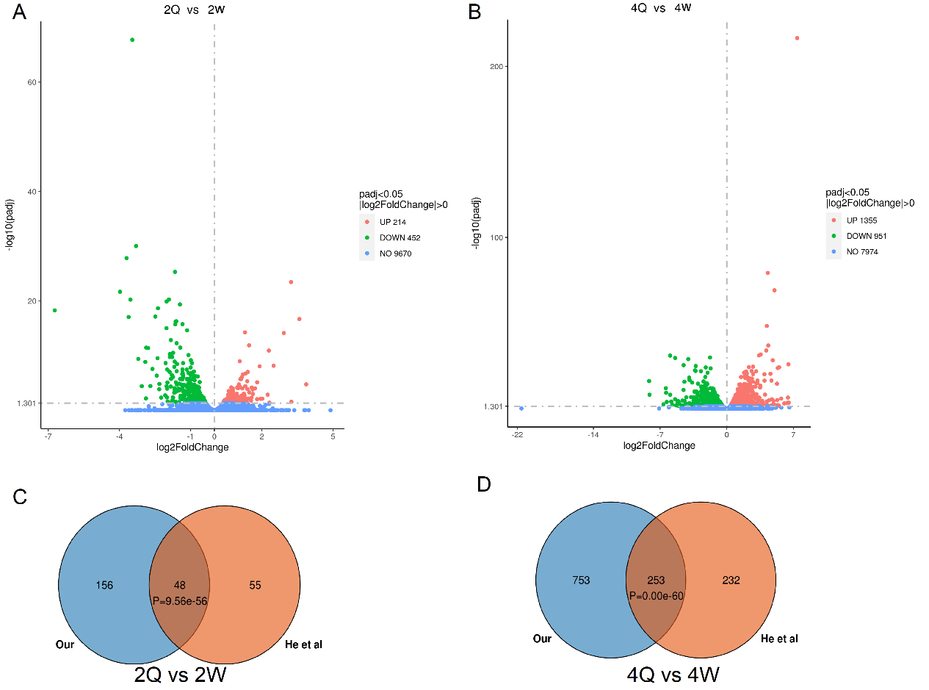**Figure S8.** Transcriptome correlation analysis. (**A**) Volcano plot of DEGs in 2Q vs 2W comparison. Red dots are up-regulated DEGs, green dots are down-regulated DEGs, and blue dots are genes with no difference. (**B**) Volcano plot of DEGs in 4Q vs 4W comparison. Red dots are up-regulated DEGs, green dots are down-regulated DEGs, and blue dots are genes with no difference.